Project Design Phase-II
Data Flow Diagram & User Stories – E-Commerce System
Date: 06-12-2025
Name: Sanjeevi.M
Project Name: ShopEase – E-Commerce Web Application Maximum Marks: 4 Marks
Data Flow Diagrams
A Data Flow Diagram (DFD) represents how data moves inside the ShopEase E-Commerce platform.
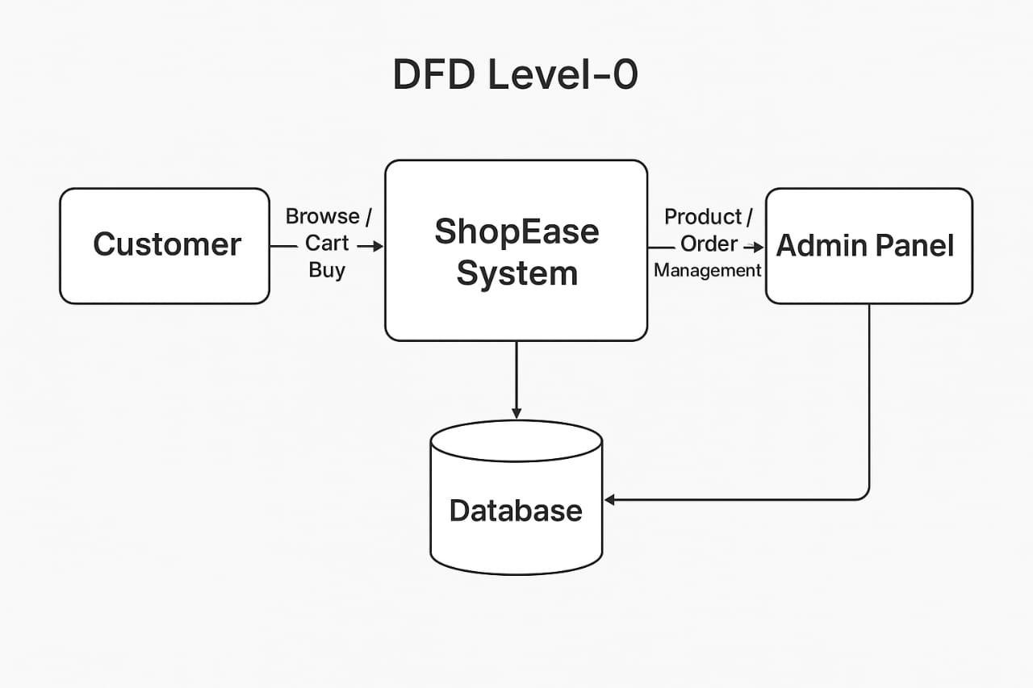
DFD Level-0 (Context Diagram)

DFD Level-1
- User Module
  - User registers / logs in (JWT)
  - User updates profile
  - User views order history
- Product Module
  - View products list
  - Search products
  - Filter by category, gender, price
- Cart Module
  - Add to cart
  - Remove from cart
  - Update quantity
- Order Module
  - Checkout
  - Place order
  - Payment integration
  - Track orders
- Admin Module
  - Add/edit/delete products
  - Upload product images
  - View all orders
  - Update order status
User Stories – ShopEase

Story No. | User Role | User Story
US-01 | Customer | Browse all products easily
US-02 | Customer | Filter products by

 |  | category/gender/price
US-03 | Customer | Add items to cart
US-04 | Customer | Place an order securely
US-05 | Admin | Manage products with images
US-06 | Admin | View and manage orders
US-07 | Admin | Update order status
US-08 | Customer | Search products quickly

